**Experimental Log**

**November 20th**

**Core Task**: Sorting out reviewer comments

**Specific Work Content**: Conduct a detailed review of comments from 3 reviewers.

Establish revision priorities: Supplementary experiments take precedence, principle verification and expression revision are carried out alternately, and format/figure optimization is completed at the end.

**Completion Status**: Fully completed.

**November 21st**

**Core Task**: Preparation for comparative experiments on SCR_R4Net depth channel initialization

**Specific Work Content**: Addressing the reviewer 1’s comment that "depth channel initialization lacks basis", build the experimental environment, load the pre-trained ResNet-18 model, and configure training parameters (batch size=16, learning rate=0.0001, weight decay=0.00001); design 3 comparative schemes (R/G/B channel weight initialization), write data recording scripts, and clarify statistical indicators (MSE, convergence epochs, MAE).

**Completion Status**: Fully completed. The experimental environment is debugged and ready for training at any time, ensuring a response to the only model design-related experiment required by the reviewer.

**November 22nd - November 23rd**

**Core Task**: Operation and result collation of SCR_R4Net initialization comparative experiments

**Specific Work Content**: Launch 3 groups of experiments on November 22nd, monitor the training process in real time, and record MSE changes for each epoch; wait for experimental convergence on November 23rd, and finally confirm the training data of R-channel initialization (converged at 37 epochs), G-channel (82 epochs), and B-channel (77 epochs); count MSE and MAE indicators and organize them into a comparative table to provide empirical support for model design.

Table Performance Comparison of Depth Channel Initialization Strategies

|  |  |  |  |
| --- | --- | --- | --- |
| Initialization Method | MSE | Convergence | Epochs |
| R channel | 0.0083 | 0.105 | 37 |
| G channel | 0.0085 | 0.112 | 82 |
| B channel | 0.0079 | 0.121 | 77 |

**Completion Status**: Fully completed. The experimental data verifies the convergence efficiency advantage of R-channel initialization, meeting the reviewer’s requirements for design basis.

**November 24th - November 25th**

**Core Task**: Comparative experiment of DIF and DIF(log) indicators

**Specific Work Content**: Addressing reviewer 1’s comment that "indicator selection lacks basis", theoretically demonstrate that DIF has a more direct physical interpretation (millimeter-level height difference).

**Completion Status**: Fully completed. The requirement is supplemented through theoretical analysis.

**November 26th - November 27th**

**Core Task**: Expansion and experimental preparation of robustness verification dataset

**Specific Work Content**: Addressing reviewer 2’s comment that "lack of verification in real industrial environments", build an interference scenario platform (illumination variation, surface coating, 20% occlusion) on November 26th, capture 24 samples per group, and synchronously record real distances with a laser rangefinder for labeling; supplement capturing samples of 50% occlusion, highly reflective surfaces, and oil contamination scenarios on November 27th, screen to form an extended dataset of 144 images, and complete classification and collation.

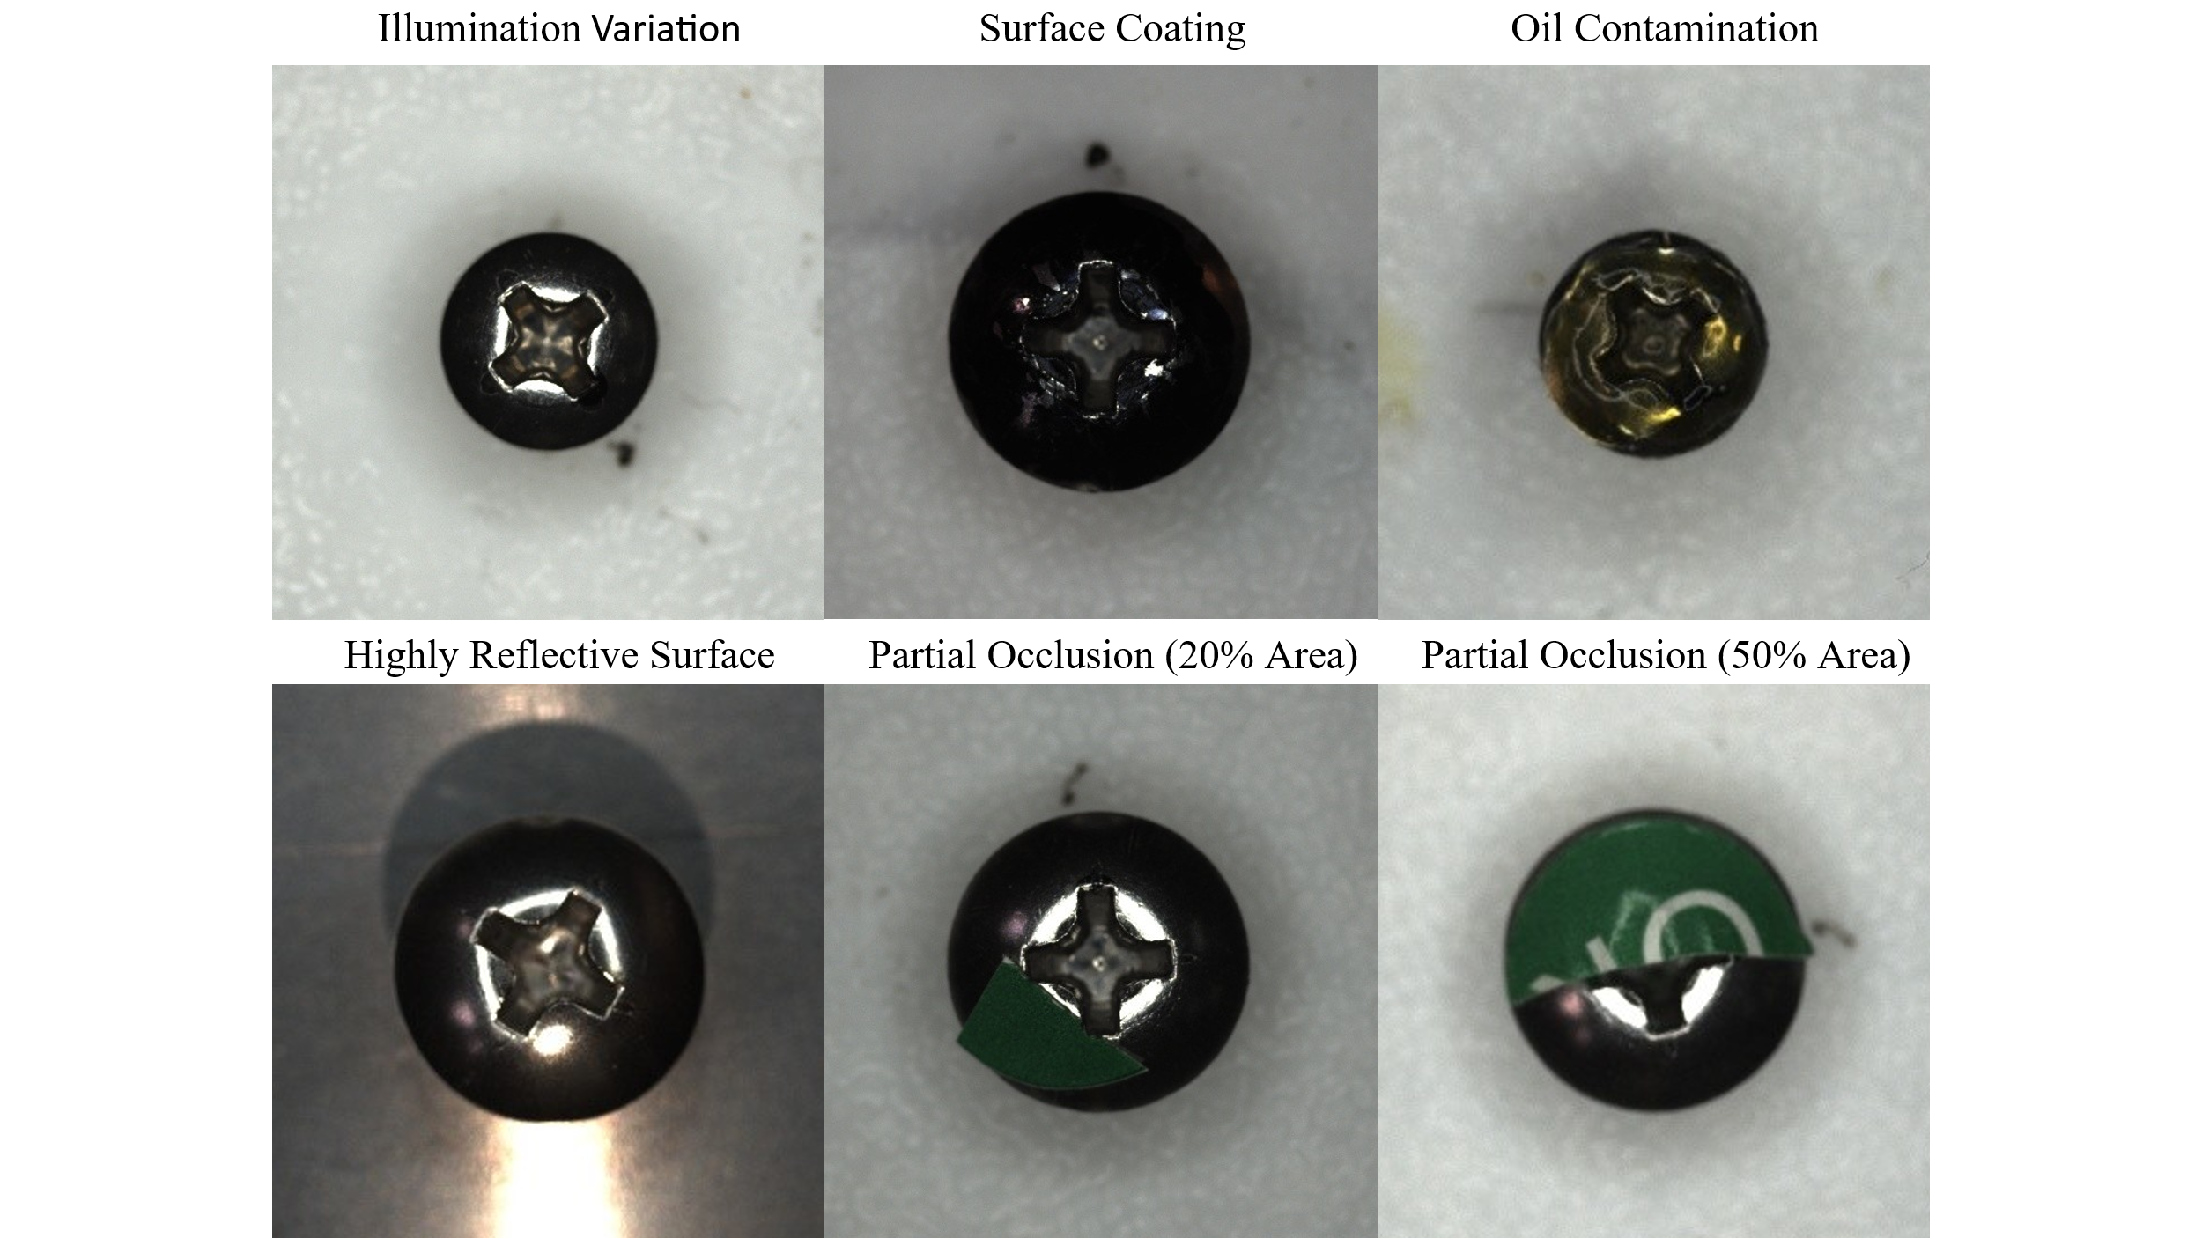

Screw Pictures under Different Interferences

**Completion Status**: Fully completed. The extended dataset meets the requirements for robustness testing and provides data support for subsequent experiments.

**November 28th - November 30th**

**Core Task**: Operation and data statistics of robustness experiments

**Specific Work Content**: Calculate the baseline MAE (0.277 mm) under normal conditions and write performance retention rate calculation code on November 28th; input the extended dataset into the model for testing on November 29th, count MAE and performance retention rate under each interference scenario (108.1% for highly reflective surfaces, 67.1% for 50% occlusion), and organize experimental results into a table.

Table Robustness Verification Results Under Different Industrial Interference Conditions

|  |  |  |
| --- | --- | --- |
| Interference Condition | Mean Absolute Error (MAE, mm) | Performance Retention Rate (%) |
| Normal Condition (Baseline) | 0.277 | 100.0 |
| Illumination Variation | 0.314 | 86.8 |
| Surface Coating | 0.302 | 91.1 |
| Oil Contamination | 0.360 | 70.2 |
| Highly Reflective Surface | 0.253 | 108.1 |
| Partial Occlusion (20% Area) | 0.301 | 91.4 |
| Partial Occlusion (50% Area) | 0.531 | 67.1 |

**Completion Status**: Fully completed. The experimental data quantifies the model’s performance in complex environments, responding to the reviewer’s query about robustness.

**December 1st - December 3rd**

**Core Task**: Depth estimation uncertainty analysis (data statistics + theoretical demonstration)

**Specific Work Content**: Addressing reviewer 2’s comment that "no error quantification", count the depth estimation errors of Depth Anything V2 (MAE, standard deviation, 95% upper error bound); theoretically analyze the characteristic that "depth estimation errors in the screw region and background are spatially positively correlated", and demonstrate the offset effect of differential operation on systematic bias; count the MAE (0.02-0.09 mm) and confidence interval of the final distance prediction, and integrate data and theory to form a complete analysis.

Table Statistical Analysis of Depth Estimation Errors (unit: mm)

|  |  |  |  |  |
| --- | --- | --- | --- | --- |
| Statistical Metric | Screw1 | Screw2 | Screw3 | Screw4 |
| Mean Absolute Error (MAE) | 0.19 | 0.07 | 0.05 | 0.12 |
| Error Standard Deviation (Std) | 0.10 | 0.05 | 0.03 | 0.06 |
| 95% Error Upper Bound* | 0.37 | 0.17 | 0.12 | 0.25 |

Table Screw-to-Surface Distance Prediction Error Statistics of Test Set (unit: mm)

|  |  |  |  |  |
| --- | --- | --- | --- | --- |
| Statistical Metric | Screw1 | Screw2 | Screw3 | Screw4 |
| Mean Absolute Error (MAE) | 0.02 | 0.05 | 0.09 | 0.02 |
| Error Standard Deviation (Std) | 0.05 | 0.05 | 0.06 | 0.04 |
| 95% Error Upper Bound* | 0.12 | 0.15 | 0.21 | 0.11 |

**Completion Status**: Fully completed. Supplement experimental information, and meet the requirements of error propagation analysis through data statistics + theoretical derivation.

**December 4th - December 5th**

**Core Task**: Writing responses based on theoretical verification (Depth Anything V2 defects and remediation mechanisms)

**Specific Work Content**: Addressing reviewer 1’s comment that "Depth Anything V2 defects are not mentioned", write Section 3.1 based on method principles; clarify the depth prediction degradation problem of this model in low-texture regions (screw heads), systematically elaborate the remediation mechanism of "edge mask fusion" (geometric contour constraint + visual feature complementarity), and explain how it suppresses error propagation and ensures that features reflect real physical scales.

**Completion Status**: Fully completed. Strengthen research innovation through theoretical logical demonstration and respond to the reviewer’s requirement for a critical perspective.

**December 6th**

**Core Task**: Failure case analysis + confusion matrix generation + clarification of expression boundaries

**Specific Work Content**: Addressing reviewer 2’s comment that "no failure case analysis", generate a confusion matrix for the four-classification task; select typical failure cases and analyze the root causes from the perspective of feature extraction failure; address the comment of "exaggerated expressions", revise core concepts: clarify that "marker-free" means no manual annotation is required, "robustness" targets common industrial interferences, and clarify the standardization requirements for imaging conditions.

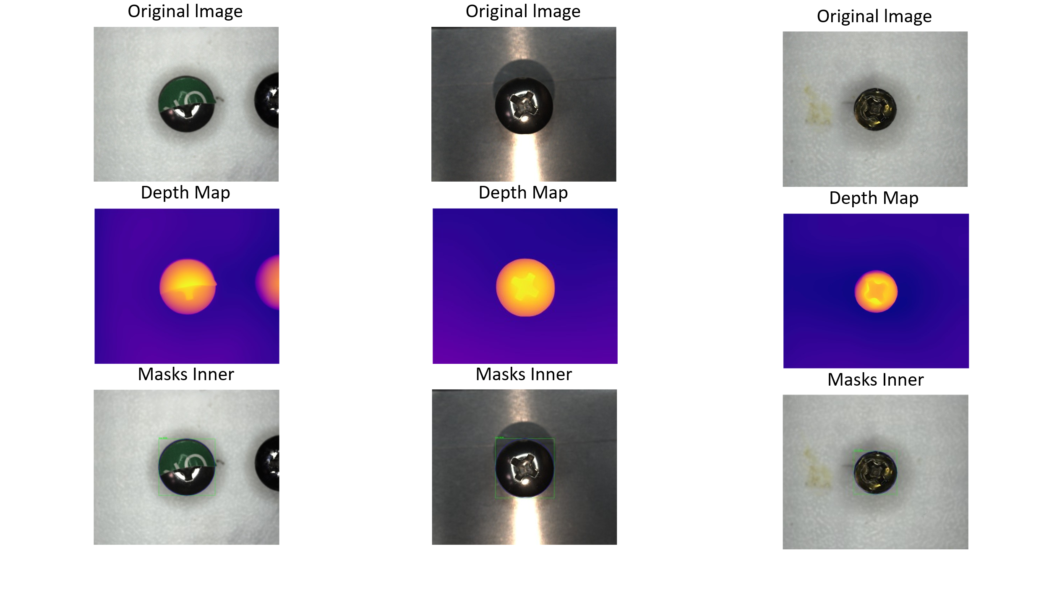

Pictures of Failure Cases

**Completion Status**: Fully completed. Respond to the reviewer’s queries about method limitations and expression accuracy through data visualization and logical clarification.

**December 7th - December 8th**

**Core Task**: Responding to non-experimental comments (format revision + dataset detail supplement)

**Specific Work Content**: Addressing reviewer 2’s comments on "format and dataset details", supplement the calibration process of the laser rangefinder (calibrated against standard references) and data repeatability verification instructions; calculate MAE variance data of the training/validation/test sets to verify model generalization stability; standardize the full-text format (unify "Network(SCR_R4Net)" and "bolt" to "screw"); address the comment of "comparison with traditional 3D methods", clarify that the research focus is on the monocular vision framework, no additional comparative experiments are needed, and confirm that "low cost" stems from the inherent advantage of only requiring an RGB camera.

**Completion Status**: Fully completed. Respond to all relevant comments through detail supplement and logical clarification; answer the comment of "comparison with traditional 3D methods" in the response letter by investigating relevant technologies and papers.

**December 9th**

**Core Task**: Figure optimization + language refinement

**Specific Work Content**: Addressing reviewer 3’s comments that "figure resolution is low and subfigures lack explanations", redraw Fig.2 (improved to publication standards), supplement subfigure descriptions for Fig.3 (corresponding explanation of RGB images and depth maps) and Fig.6 (classification explanation of dataset samples); read the full text to refine language (e.g., revise "noncontact vision methods have attracted widespread attention" to "non-contact vision methods are increasingly adopted") and correct redundant expressions.

**Completion Status**: Fully completed. The quality of figures and language meets the standards.

**December 10th**

**Core Task**: Final integration and submission preparation

**Specific Work Content**: Read the full text to check whether all 11 reviewer comments are responded to, ensure the accuracy of experimental results, completeness of theoretical demonstrations, and in-place revision of expressions; organize the final version of the paper (including figures, tables, and references); confirm that all revisions are clearly marked, check logical consistency and data accuracy, and prepare formal submission materials.

**Completion Status**: Fully completed.